VISVESVARAYA TECHNOLOGICAL UNIVERSITY
Jnana Sangama, Belgaum-590018
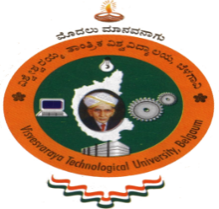

A Web Application Mini Project Report
on
“GAMER’S PARADISE”

Submitted in Partial fulfillment of the Requirements for the VII Semester of the Degree of
Bachelor of Engineering
In
Computer Science & Engineering
By
PAWAN.V
(1CR16CS114)

Under the Guidance of

Mrs. Gopika
Assistant Professor, Dept. of CSE

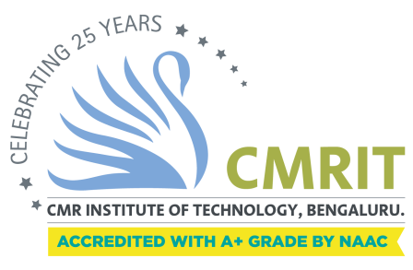

DEPARTMENT OF Computer SCIENCE AND ENGINEERING
CMR INSTITUTE OF TECHNOLOGY
#132, AECS LAYOUT, IT PARK ROAD, KUNDALAHALLI,
BANGALORE-560037
CMR INSTITUTE OF TECHNOLOGY
#132, AECS LAYOUT, IT PARK ROAD, KUNDALAHALLI,
BANGALORE-560037

DEPARTMENT OF Computer SCIENCE AND ENGINEERING

CERTIFICATE
This is to certify that the Web Application Project work entitled “Gamer’s Paradise” has been carried out by Pawan.V (1CR16CS114) bonafide students of CMR Institute of Technology in partial fulfillment for the award of Bachelor of Engineering in Computer Science and Engineering of the Visvesvaraya Technological University, Belgaum during the year 2018-2019. It is certified that all corrections/suggestions indicated for Internal Assessment have been incorporated in the Report deposited in the departmental library. This Web Project Report has been approved as it satisfies the academic requirements in respect of project work prescribed for the said degree.

----------------------- ----------------------
Signature of Guide Signature of HOD
Mrs. Gopika Dr. Prem Kumar Ramesh
Assistant Professor Professor, Head
Dept. of CSE, CMRIT Dept. of CSE, CMRIT

External Viva
Name of the examiners Signature with date
1.
2.

